**Project item 3**

**ER Diagram Draft:**

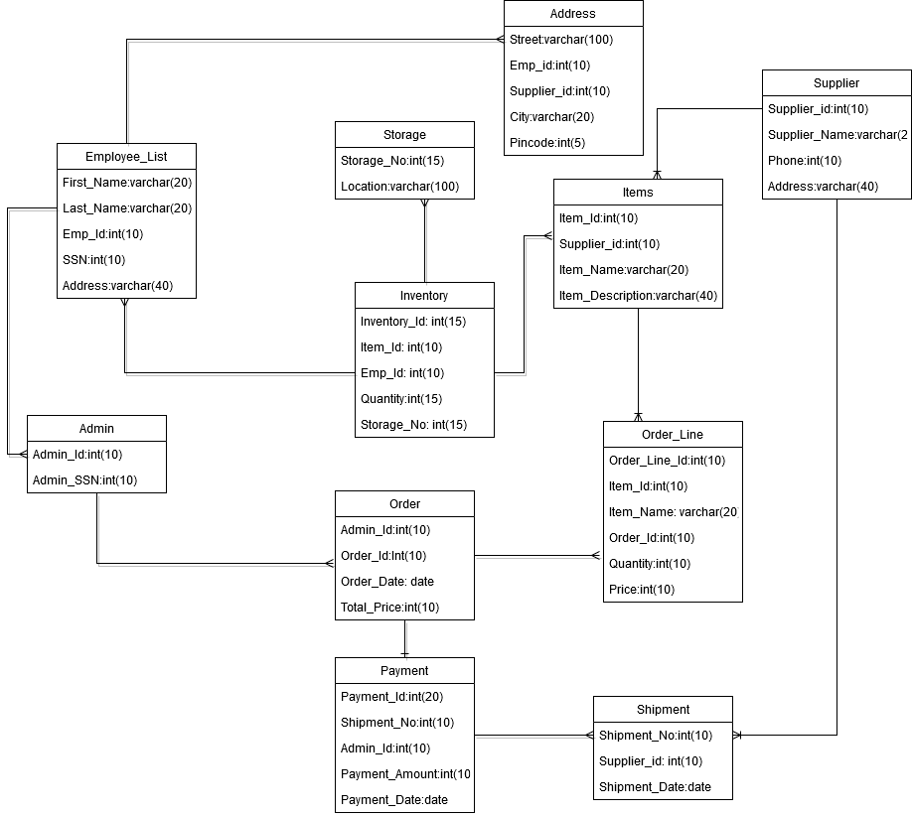

**Revised ERD [Final version] –**

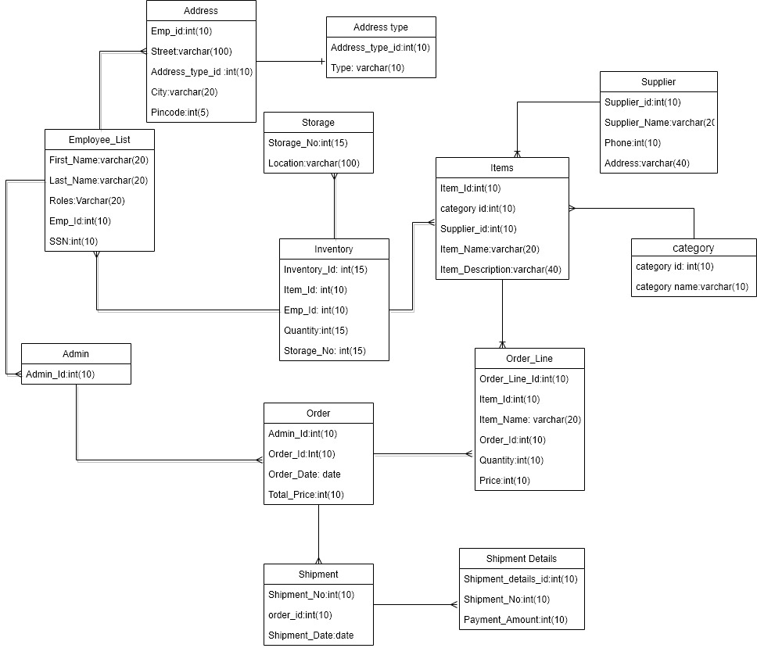

**Tables created:**

All 13 tables created successfully.

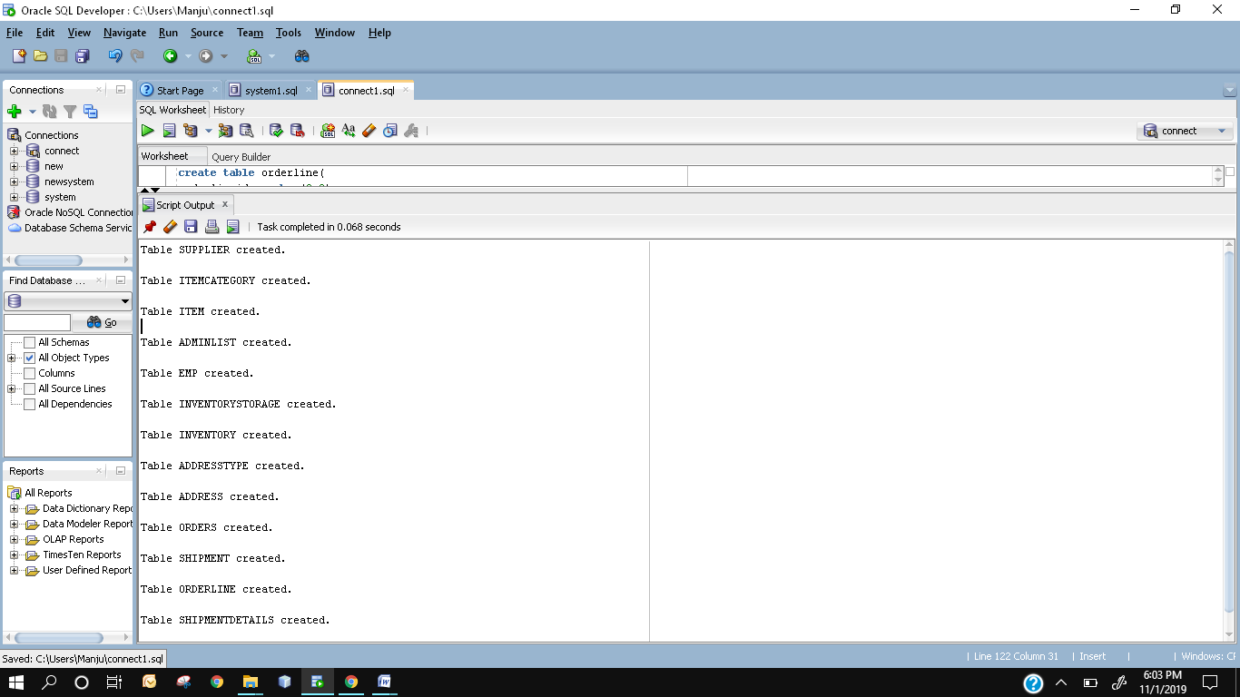

**Inserting Values in Tables**

1. **Supplier table**

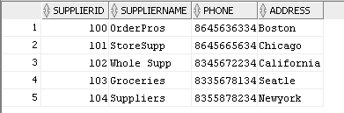

1. **Item category table**

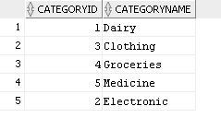

1. **Item table**

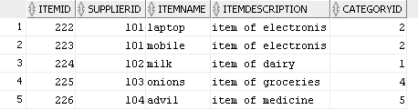

1. **Adminlist table**

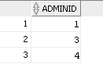

1. **Emp table**

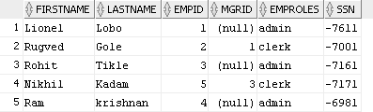

1. **Inventory Storage table**

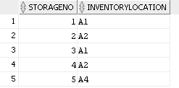

1. **Inventory table**

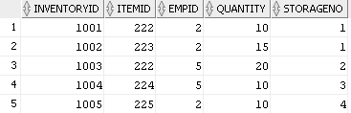

1. **Addresstype table**

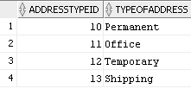

1. **Address table**

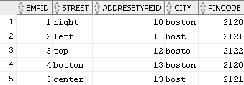

1. **Orders table**

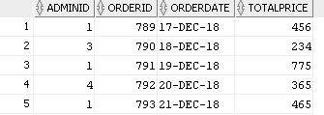

1. **Shipment table**

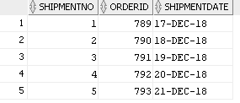

1. **Order line table**

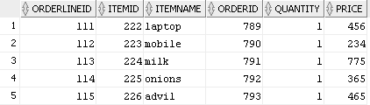

1. **Shipment details table**

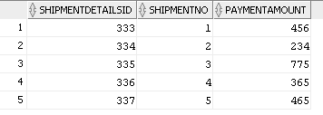

**Business rules**

**Inventory**

* Inventory consists of multiple items
* An inventory can have multiple storage locations
* Inventory_id will be same for all items i.e., all items belong to the same inventory
* Inventory can hold 200 item_ids.
* Multiple employees are associated to one inventory
* Inventory should be updated daily

**Item**

* Each item_id will have separate storage area for it(storage_no).
* An item_id can have one or more suppliers.
* Different Items can have different prices.
* An item should belong to an inventory.

**Employee/Admin**

* An employee should have valid SSN
* More than 1 employee can be an admin
* All employees are not admin.
* Admin’s admin_id and employee emp_id will be same
* An employee can have one or more addresses.
* Employee should keep track of daily purchases.
* Only an admin can make an order.
* Admin can make multiple orders.
* Admin can make changes to the database.

**Supplier**

* Each supplier will have different price for different items
* A supplier can have multiple address
* A supplier can supply different items.
* A supplier will supply item on a particular date

**Order**

* An order_id can have only one Admin_id
* There can be one or many items in single order_id
* One order can have multiple orderline
* An order can consists of a list of items
* An employee cannot place an order
* One order can have multiple shipments

**Order Line**

* One order_line_id can have only one Order_id
* An orderline can consists of multiple items
* An orderline should consist of the price and the quantity of items.
* Orderline is accessible by only the admin.

**Shipment**

* one shipment will have one order id
* one order can be shipped at different dates

**Shipment details**

* Shipment details is associated to one shipment
* Shipment will have a amount paid for shipment

**Storage**

* A storage_no can have only one Location
* One inventory can have multiple storage areas
* Storage will consists of categories of items
* Depnending upon the storage the quantity of the inventory will be decided

**Define Security (User level access, permissions):**

|  |  |  |
| --- | --- | --- |
| Privilege | Object type | Description |
| All  System privileges | Admin | Confers unlimited database privileges for the database and ability to specify effective user. They have all access like Update, delete, create, insert drop, manage and view user permissions.  Admin will be able to perform all operations on all tables such as inventory, storage, order line, payment, supplier, shipment so on.  Moreover, all configurations, maintenance activities also dropping the database etc. |
| VIEW access | Supplier | Supplier cannot update Item id, descriptions and price of the item. They only have read access to view the placed orders and items available in inventory. |
| Read Only | Employee | Employees will only have view access except Director, manager and analyst these are also employees, but their permissions will be different as in they will be able to modify, create and delete operations. |

**SQL QUERIES**

create table supplier(

supplierid number(9,0),

suppliername varchar2(10),

phone number(10,0),

address varchar2(30),

constraint pk_supplier primary key (supplierid)

)

INSERT INTO supplier (supplierid, suppliername, phone, address)

VALUES (100, 'OrderPros', 8645636334, 'Boston');

INSERT INTO supplier VALUES (101, 'StoreSupp', 8645665634, 'Chicago');

INSERT INTO supplier VALUES(102,'Whole Supp',8345672234, 'California');

INSERT INTO supplier VALUES(103,'Groceries',8335678134, 'Seatle');

INSERT INTO supplier VALUES(104,'Suppliers',8355878234, 'Newyork');

select * from supplier;

create table itemcategory(

categoryid number(9,0),

categoryname varchar(10),

constraint pk_categoryid primary key (categoryid)

)

INSERT INTO itemcategory VALUES (1, 'Dairy');

INSERT INTO itemcategory VALUES (2, 'Electronic');

INSERT INTO itemcategory VALUES (3, 'Clothing');

INSERT INTO itemcategory VALUES (4, 'Groceries');

INSERT INTO itemcategory VALUES (5, 'Medicine');

select * from itemcategory;

create table item(

itemid number(9,0),

supplierid number(9,0),

itemname varchar2(10),

itemdescription varchar2(30),

categoryid number(9,0),

constraint pk_item primary key (itemid),

constraint fk_supplier foreign key (supplierid) references supplier(supplierid) ON DELETE CASCADE,

constraint fk_categoryid foreign key(categoryid) references itemcategory(categoryid) ON DELETE CASCADE

)

INSERT INTO item VALUES (222, 101, 'laptop', 'item of electronis', 2);

INSERT INTO item VALUES (223, 101, 'mobile', 'item of electronis', 2);

INSERT INTO item VALUES (224, 102, 'milk', 'item of dairy', 1);

INSERT INTO item VALUES (225, 103, 'onions', 'item of groceries', 4);

INSERT INTO item VALUES (226, 104, 'advil', 'item of medicine', 5);

select * from item;

create table adminlist(

adminid number(9,0),

constraint pk_adminid primary key (adminid)

)

INSERT INTO adminlist VALUES (1);

INSERT INTO adminlist VALUES (3);

INSERT INTO adminlist VALUES (4);

select * from adminlist;

create table emp(

firstname varchar2(10),

lastname varchar2(10),

empid number(9,0),

mgrid number(9,0),

emproles varchar2(10),

ssn varchar(11),

constraint pk_emp primary key (empid),

constraint fk_mgr foreign key (mgrid) references adminlist(adminid) ON DELETE CASCADE

)

INSERT INTO emp VALUES ('Lionel', 'Lobo', 1, null, 'admin', '123-55-7489');

INSERT INTO emp VALUES ('Rugved', 'Gole', 2, 1, 'clerk', '423-35-7389');

INSERT INTO emp VALUES ('Rohit', 'Tikle', 3, null, 'admin', '523-45-7639');

INSERT INTO emp VALUES ('Ram', 'krishnan', 4, null, 'admin', '623-15-7589');

INSERT INTO emp VALUES ('Nikhil', 'Kadam', 5, 3, 'clerk', '723-05-7889');

select * from emp;

create table inventorystorage(

storageno number(9,0),

inventorylocation varchar2(10),

constraint pk_inventorystorage primary key (storageno)

);

INSERT INTO inventorystorage VALUES (1, 'A1');

INSERT INTO inventorystorage VALUES (2, 'A2');

INSERT INTO inventorystorage VALUES (3, 'A1');

INSERT INTO inventorystorage VALUES (4, 'A2');

INSERT INTO inventorystorage VALUES (5, 'A4');

select * from inventorystorage;

create table inventory(

/*inventoryid number(9,0), */

itemid number(9,0),

empid number(9,0),

quantity number(9,0),

storageno number(9,0),

constraint pk_inventory primary key (inventoryid),

constraint fk_item foreign key (itemid) references item(itemid) ON DELETE CASCADE,

constraint fk_inventorystorage foreign key (storageno) references inventorystorage(storageno)ON DELETE CASCADE,

constraint fk_emp foreign key (empid) references emp (empid)ON DELETE CASCADE

);

INSERT INTO inventory VALUES (1001, 222, 2, 10, 1);

INSERT INTO inventory VALUES (1002, 223, 2, 15, 1);

INSERT INTO inventory VALUES (1003, 222, 5, 20, 2);

INSERT INTO inventory VALUES (1004, 224, 5, 10, 3);

INSERT INTO inventory VALUES (1005, 225, 2, 10, 4);

select * from inventory;

create table addresstype(

addresstypeid number(9,0),

typeofaddress varchar2(10),

constraint pk_addresstype primary key (addresstypeid)

)

INSERT INTO addresstype VALUES (10, 'Permanent');

INSERT INTO addresstype VALUES (11, 'Office');

INSERT INTO addresstype VALUES (12, 'Temporary');

INSERT INTO addresstype VALUES (13, 'Shipping');

select * from addresstype;

create table address(

empid number(9,0),

street varchar2(10),

addresstypeid number(9,0),

city varchar(10),

pincode number(5),

constraint pk_address primary key (addresstypeid,empid),

constraint fk_addressempid foreign key (empid) references emp(empid) ON DELETE CASCADE,

constraint fk_addresstypeid foreign key (addresstypeid) references addresstype(addresstypeid) ON DELETE CASCADE

)

insert into address values (1,'right',10,'boston', 02120);

insert into address values (2,'left',11,'bost', 02121);

insert into address values (3,'top',12,'bosto', 02122);

insert into address values (4,'bottom',13,'boston', 02120);

insert into address values (5,'center',13,'bost', 02121);

select * from address;

create table orders(

adminid number(9,0),

orderid number(9,0),

orderdate date,

totalprice number(9,2),

constraint pk_orders primary key (orderid),

constraint fk_adminlist foreign key (adminid) references adminlist(adminid) ON DELETE CASCADE

)

insert into orders values (1,789,to_date('17-dec-2018','DD-MON-YYYY'),456);

insert into orders values (3,790,to_date('18-dec-2018','DD-MON-YYYY'),234);

insert into orders values (1,791,to_date('19-dec-2018','DD-MON-YYYY'),775);

insert into orders values (4,792,to_date('20-dec-2018','DD-MON-YYYY'),365);

insert into orders values (1,793,to_date('21-dec-2018','DD-MON-YYYY'),465);

select * from orders;

create table shipment(

shipmentno number(9,0),

orderid number(9,0),

shipmentdate date,

constraint pk_shipment primary key (shipmentno),

constraint fk_shipmentorderid foreign key (orderid) references orders(orderid) ON DELETE CASCADE

)

insert into shipment values (001,789,to_date('17-dec-2018','DD-MON-YYYY'));

insert into shipment values (002,790,to_date('18-dec-2018','DD-MON-YYYY'));

insert into shipment values (003,791,to_date('19-dec-2018','DD-MON-YYYY'));

insert into shipment values (004,792,to_date('20-dec-2018','DD-MON-YYYY'));

insert into shipment values (005,793,to_date('21-dec-2018','DD-MON-YYYY'));

select * from shipment;

create table orderline(

orderlineid number(9,0),

itemid number(9,0),

itemname varchar2(10),

orderid number(9,0),

quantity number(9,0),

price number(9,2),

constraint pk_orderline primary key (orderlineid),

constraint fk_orderlineitemid foreign key (itemid) references item(itemid)ON DELETE CASCADE,

constraint fk_orderlineorderid foreign key (orderid) references orders(orderid)ON DELETE CASCADE

)

insert into orderline values (111,222,'laptop',789,1,456);

insert into orderline values (112,223,'mobile',790,1,234);

insert into orderline values (113,224,'milk',791,1,775);

insert into orderline values (114,225,'onions',792,1,365);

insert into orderline values (115,226,'advil',793,1,465);

select * from orderline;

create table shipmentdetails(

shipmentdetailsid number(9,0),

shipmentno number(9,0),

paymentamount number(9,2),

constraint pk_shipmentdetails primary key (shipmentdetailsid),

constraint fk_shipmentno foreign key (shipmentno) references shipment(shipmentno) ON DELETE CASCADE

)

insert into shipmentdetails values (333,001,456);

insert into shipmentdetails values (334,002,234);

insert into shipmentdetails values (335,003,775);

insert into shipmentdetails values (336,004,365);

insert into shipmentdetails values (337,005,465);

select * from shipmentdetails;